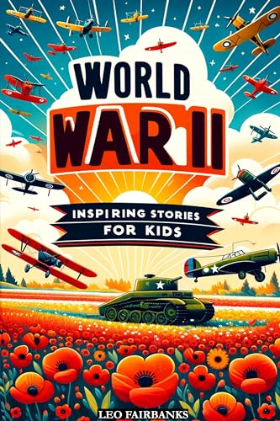
This is a book of short stories, many of them biographies. All of those who feature in the stories played a key role in the war effort, although few of them have become famous, a notable exception to this is Anne Frank. As well as her story the story of other women and their role in the war is told; code breakers, aircraft engineers and resistance fighters. As well as recounting what these incredible people did during the war the author also tells us about what may have happened to them as they returned or ordinary or ‘civilian’ life after the war ended.

I thought many of you, in Year 5 & 6 would enjoy these stories as this is part of your learning in Year 5 history, but those of you who are in Year 3 & 4 may enjoy sharing these stories with an older person. What I particularly liked about this book was the way that those people written about demonstrated so many of our school values such as resilience, empathy, peace and compassion. There was another section of the book which surprised me, but I really enjoyed – that was finding out about the role of Whiskers; she was a cat of course!

Mrs Cunnington

