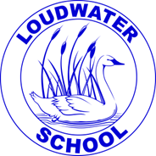
LOUDWATER UPDATE
Friday 15th September 2023
a: School Way, Kingsmead Road
Loudwater, High Wycombe
Buckinghamshire
HP11 1JJ
t: (01494) 524919
e: office@loudwater.bucks.sch.uk
w: www.loudwater.bucks.sch.uk

Loudwater Combined School
Learn, Create, Succeed
Head teacher:
Mrs. Clare Cunnington

Dear Parents,
Important Calendar Dates
Monday 18th September – Open House Meetings Y1 – Y6 (see below)
Monday 18th September – Year 5 Library Visit

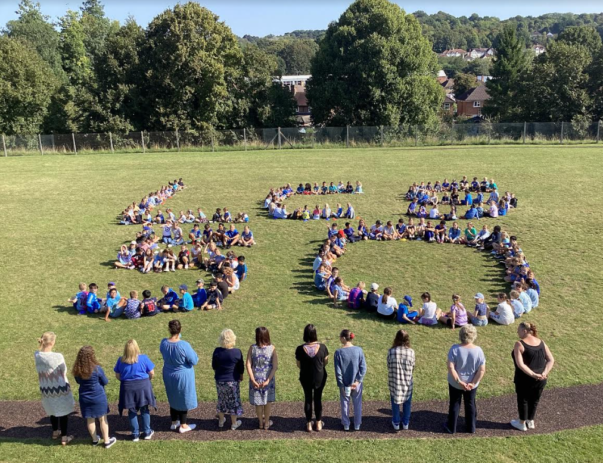
Loudwater School’s 50th Anniversary
Today we have celebrated our School’s 50th Anniversary. Years 1-6 made the letters LCS and the number 50 on the field, whilst the Foundation Stage children watched from the playground; a great piece of teamwork. We were also able to have a drone fly above us and take photographs directly above us. Many thanks to Mr Ijah Constable who came to school to do this for the children. When we have received the drone footage, we will be able to share this with you too.

We also planted a tree today to commemorate 50 years of Our Loudwater School. Miss Weston helped some of the School Council to plant the tree on the area at the front of school.
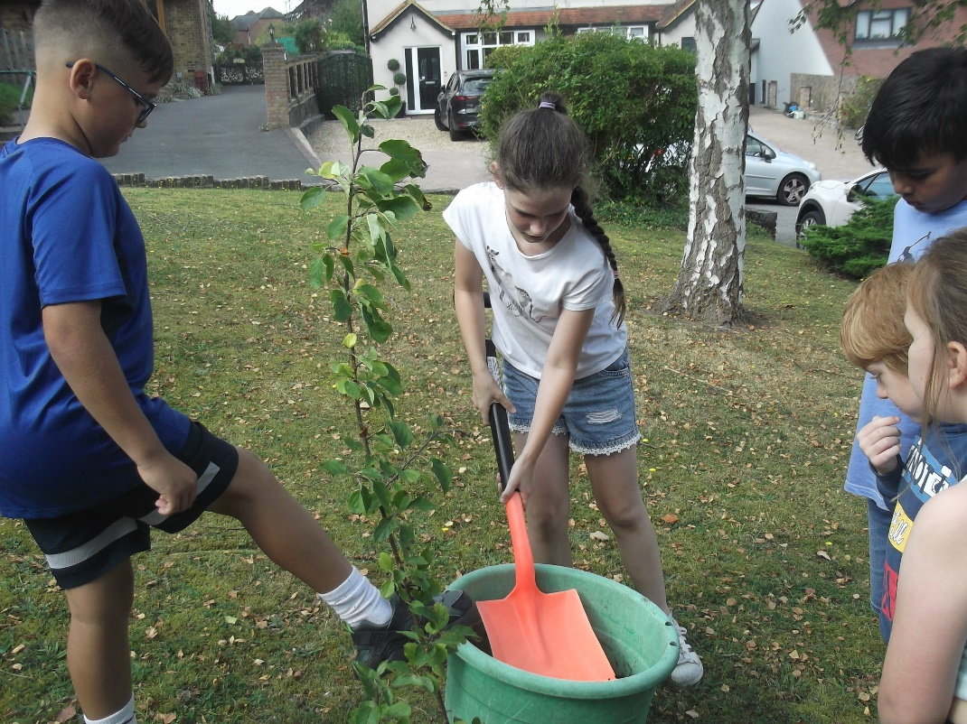

News from the classes this week:
Foundation Stage
We have completed our first full week in Foundation Stage and we are really settling in nicely now.
We are getting to know each other better and have been working on our class charter, which helps us to remember how to stay safe and happy at school. We have started our Phonics lessons and have been learning to read and write the sounds s & a. We will learn two more sounds next week and then we will have a Sound Book to bring home to help us practise the sounds we have learnt.
We have been singing lots of counting songs and recognising numbers around our classroom.

Year One
Another lovely week in Year 1!
This week in English we have continued to enjoy spider poetry. We have also enjoyed researching facts about spiders. We have become spider experts! We have been busy writing brilliant information sentences about spiders. We worked hard to try to remember to use capital letters, full stops and finger spaces. We also used some great vocabulary such as prey.
In our phonics lessons, we have been learning about ie (as in pie) and y (as in spy). We have also been learning to read and spell the words come, do and so.
In Maths, we have been finding different ways to represent numbers to 10. We used numbers, words, 10 frames, numicon and counters. Counting on from any number and finding one more than a number has also been a focus of our lessons this week. These games are useful if you want to practice what we have learnt in class this week.
Matching numbers to words game
https://www.sheppardsoftware.com/math/early-math/number-words-fruit-splat-game/
(Select option 1 to 10)
https://www.topmarks.co.uk/learning-to-count/teddy-numbers
In Art we have been experimenting with the technique of wax resist. We then used this technique to create a super celebration picture. In Computing, we have been exploring the technology that is all around us. When you are at home perhaps, you could ask your children to identify technology in the home. In PSHE, we have been thinking about similarities and differences between each other. We have been focussing on celebrating differences and the importance of being unique. ‘Giraffes can’t dance’ and ‘Elmer’ have been stories we have used to illustrate this.

Year Two
In Phonics, we have been revisiting the sound ‘ee’. We have learned all the different ways of spelling the sound ‘ee’. For example: ‘ea’ as in teach, ‘e_e’ as in even, ‘y’ as in funny, ‘ie’ as in thief, ‘ey’ as in monkey and ‘e’ as in secret. In Guided Reading, we have begun to enjoy the story ‘George’s Marvellous Medicine’ by Roald Dahl. We have focused on the vocabulary used to describe Grandma and making predictions and inferences about what might happen next.
In English, we have been writing riddles about unusually named animals such as a Blob Fish and a Bone-eating Snot Flower Worm. We have learned to use the important features of a riddle and to consider the order of the clues.
In Guided Maths, we have explored the concept of greater than and less than. We began to use the symbols < and > to compare numbers. In Maths, we have been partitioning tens and ones using a variety of resources, such as part-whole models, ten frames, place value charts and base 10. We also learned how to write numbers in numerals and words. In PSHE, we explored the feeling of loneliness and what we could do if we or someone else feels lonely. In Art, we considered how Georges Seurat’s artwork makes us feel and what we like or do not like about some of his paintings. Then we experimented with different tools to create our own painting using pointillism. In PE, we learned different types of jumps and how to land safely. In Computing, we learned about different devices that are Information Technology. We considered why and when we use these devices. This week, we had our first visit to Flackwell Heath library where we borrowed 30 new books to share in our classroom.
https://sso.readingeggs.com/login
https://www.topmarks.co.uk/learning-to-count/place-value-basketball

Year Three
This week in Maths, we have continued learning about place value. We have learnt how to represent hundreds in different ways. We have also represented numbers to 1,000 by using Base 10 and other maths resources. We have learnt how to partition numbers up to 1,000, using both traditional and flexible partitioning.
In English, we have been writing our revolting rhyme poem. First, we learnt about nouns and pronouns, and then completed a comic strip retelling one of the poems. Then, we discussed and identified features of narrative poems. Lastly, we used those features to write our class poem based on Goldilocks and the Three Bears.
In PSHCE, we have continued learning about relations and friendships. This week, we learnt about what we can do to improve and maintain friendships. We discussed some negative scenarios that may occur within friendships and then explored different ways of solving them. We then wrote different ways we improve friendships. In Art, we have been replicating Julien Opie's art of the Blur album cover. We have created self-portraits. We used tracing paper and pastilles to complete our art.
https://play.ttrockstars.com/
https://www.julianopie.com/

Year Four
During our English lessons this week, we have been busy writing shape poems. First, we worked as a class to come up with ideas for a poem about a King Cobra, and followed a 6-line verse structure to write two verses, before transferring our poem into the shape of the snake. We then used the same structure to write a poem about an animal of our choice, before publishing our final poems into their shapes. During our reading lessons, we have continued to read different examples of shape poems, and practise our performance poetry.
During our maths lessons, we have continued with our work on place value. We have looked at thousands for the first time and started to work with four-digit numbers. We have practised counting in multiples of 1,000 and compared this to counting in multiples of other numbers. We have also represented four-digit numbers in different ways, for example with base 10 or using place value counters.
During our art lessons, we have taken landscape photographs of our local area, thinking carefully about the foreground and background. We then used these photos and created paintings in the style of our artist, Catherine Rayner, to create monochrome landscape paintings. During our PSHE lesson, we explored self-esteem and how to build self-esteem. In our Spanish lessons, we have recapped our Spanish learning from year three. During our Music lesson, we continued to learn the song 'This Little Light of Mine'.
https://ttrockstars.com/

Year Five
In Maths this week we have been furthering our knowledge of Place Value, working with numbers up to 1,000,000. We have built and ‘drawn’ a number using place value counters and a place value chart. We have also had to partition 5-digit numbers and have identified numbers using clues.
Our English and Art lessons have overlapped this week as we have explored Haiku poetry. On Monday, we went on a ‘Haiku hunt’ in our school grounds, where we identified plants, insects, spiders, seed pods, trees, flowers and the willow walk as possible inspiration for writing our own Haiku. We learnt about the features of a Haiku and understand the importance of vocabulary choices, including verb choices when composing a poem. In Guided Reading lessons, we worked hard to memorise and perform Spike Milligan’s poem: Silly Old Baboon in preparation for our whole-school sharing assembly next week.
In Art, we designed and created a collagraph (a simple printing tile) to produce an image of our chosen aspect of nature in our outdoor learning area. We then used this to print a repeated pattern in our sketch books and to illustrate our own Haiku. In RE, we learnt about a Christian rite of passage – baptism - and reflected on the meaning of this. We explored the significance of influence in PSHE and considered the question: What and who may influence us in our lives? In Spanish lessons, we have completed both a verbal and written mini-quiz, recapping previous topics and warming-up our brains for the new Term.
All Year 5 pupils have now completed a diagnostic assessment for the Maths Whizz Tutoring Plus programme, which offers tailored tutorials, activities and quizzes for each student. Pupils have their user names and log-ins stuck in their purple Reading Journals and should access this at home as part of their home-learning. Short 20-minute sessions are most effective.
Online Maths Tutor For 5-13yr olds | Learn Maths Online | Whizz Education Mrs PC will explain more about home-learning expectations at our Open House meeting next Monday.

Year Six
It has been another busy week in Year 6. In English, we have continued to use the poem – The Jabberwocky by Lewis Carroll to inspire us in our writing. We have planned the opening, build-up, climax and ending of the narrative of the poem, thinking carefully about each verse and the main events. We have explored a range of sentence openers and precise vocabulary that we can use in our writing next week. In Spellings, we have continued to recap some of the spelling patterns from Year 5 such as –ough letter string, homophones which are nouns and verbs e.g. advice and advise, words ending with –tious, -cious, -able, -ible, -ant and –ent. In Guided Reading, we have started to read and explore the vocabulary of Boy – Tales of Childhood by Roald Dahl which is the book that we will be using in our next writing unit of work.
In Maths, we have continued our learning on place value. We have used number lines up to 10 million and have compared and order any integer (whole number).
In our Art unit, we have been completing our own city landscapes with flowing contour lines inspired by the Austrian architect and artist, Friedensreich Hundertwasser. In PSHE we have discussed what the signs are that a person’ physical and mental health is not good and have looked at the activities that a person could do every day, sometimes, if there is a problem or rarely/not at all to maintain good physical health. In RE, we have reminded ourselves what we know about Christianity. We then explored some aspects of the life of Jesus. On Tuesday (practice) and Thursday we sat our Secondary Transfer Tests (11+). This week in class, we have been listening to the music of Tom Jones.
Website –
BBC Bitesize – KS2 – Electricity – a great website to prepare for our next topic in Science.
https://www.bbc.co.uk/bitesize/topics/zj44jxs

Dates for visits to Flackwell Heath Library
We will be resuming our weekly visits to Flackwell Heath Library from Monday. The dates for each class are:
18th September Year 5
25th September Year 4 2nd October Year 3
9th October Year 1 16th October Year 6
30th October Year 2 6th November Year 5
13th November Year 4 20th November Year 3
27th November Year 1 4th December Year 6

Open House Meetings
On Monday 18th September, we will be holding our Open House meetings for Years 1 to 6. This is for parents to visit their child’s new classroom, listen to a presentation from the class teacher and ask any questions they may have.
The presentations will be at 3.45pm and 4.15pm so that parents with children in different classes will be able to attend both meetings.
There will be members of staff on the Key Stage 2 Playground to look after the children whilst parents are in the meetings. Please could parents of children in Year 1 and Year 2 bring their children to the Key Stage 2 playground before attending the meeting; at the end of the meeting, please come to the playground to collect your child/ren.

Book Review
Please see the attachment for this week’s book review by Mrs Welland

Achievement Award Winners
 | Foundation Stage | Year One | Year Two | Year Three | Year Four | Year Five | Year Six
08/09/23 | Attending part time | Maya | Jayden | Yanis | All pupils | Caleb | Finley
15/09/23 | Attending part time | Peter | Janeil | Ronnie | Diya | Paige | Joshua

The following children have been recognised in achievement assembly for their good behaviour:
 | Foundation Stage | Year One | Year Two | Year Three | Year Four | Year  Five | Year Six
08/09/23 | Attending part time | Ivy  Ollie | Holly  Prince | Natalia  Ronnie | Zain  Lilien | Imogen  Samuel | Callum  Kata
15/09/23 | Attending part time | Eshal  Sarah | Harrison  Sienna | Noemi  Hayden | Tilly  Thomas | Esme  Max | Tilly  Joseph

The following children, in KS2, have made particular efforts with Tables Rock Stars:
 | Times Tables Rock Stars
15/09/23 | Ahil – Y3  Amelia – Y4  Kelci – Y5  Julia – Y6

Attendance
 | Foundation Stage | Year One | Year Two | Year Three | Year Four | Year Five | Year Six
08/09/23 | Attending part time | 98% | 92% | 91% | 93% | 100% | 99%
15/09/23 | 96% | 97% | 97% | 94% | 97% | 96% | 100%

Punctuality
Number of children arriving after their class start time.
 | Foundation Stage | Year One | Year Two | Year Three | Year Four | Year Five | Year Six
08/09/23 | Attending part time | 0 | 3 | 0 | 2 | 0 | 0
15/09/23 | 0 | 0 | 0 | 0 | 2 | 0 | 0

House points for the week
 | Beethoven | Mozart | Tchaikovsky | Elgar
08/09/23 | 149 | 167 | 145 | 168
15/09/23 | 175 | 202 | 169 | 190

Gemma (Family Support Adviser)
Gemma’s contact details:
Work mobile number: 07792 142825.
School email: gnortheast@loudwater.bucks.sch.uk

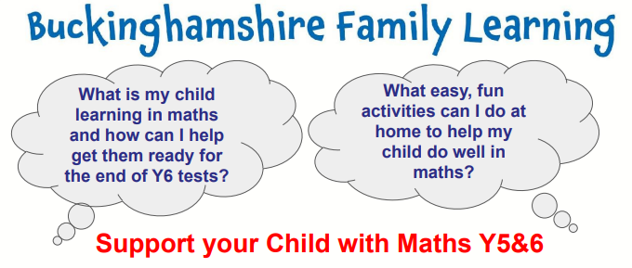
Family Learning Team - Supporting your child with Maths (Year 5 and Year 6)

Please find attached the leaflet for a free online 5-week course available for all parents and carers of children in Year 5 and Year 6.

By following the link on the leaflet or calling the enrolment team, you will be able to book your place on the course. Please contact me if you need any assistance with this.

One Can Trust – Harvest Donations
This year we will continue to support the One Can Trust to help provide support for families in our local community.
If you would like to help donate food items, please see the attached leaflet to see what the priority items are at this time of year.
Items will be collected in the entrance to the school office so please hand any donations into the school office.
Thank you in advance for your support.

Lending Library – Every Thursday
I would like to make you aware that the Lending Library has continued this academic year. Every Thursday, you will have an opportunity to choose some games to take home and play with your children. The following Thursday you can simply return your borrowed items and choose some more!

Top Up Tuesdays – Pre-loved uniform
'Top Up Tuesdays' will continue to happen every Tuesday, available in the mornings at drop off and after school during pick up. The purpose of ‘Top UP Tuesdays’ is to help be sustainable and provide the school community with a chance to purchase good quality uniform items for a fraction of the cost.
Please take some time to look through a range of pre-loved uniform, donated to the school by other families and purchase an item of school uniform for a suggested donation of £1 per item. All money raised will be given to FOLS to help support the school.

We have got the following items:
* Polo tops
* Shirts, shorts and trousers
* Pinafore dresses and summer dresses
* Summer caps
* Jumpers
* PE hoodies, PE tops and joggers, shorts and leggings
* Loudwater draw-string bags and book bags

Is your child too ill for school?
Please see the information on the link here for some useful advice from the NHS about whether your child should attend school if they feel unwell. In many cases of mild ailments, children should still attend school.

Would you like to make a difference to our school by becoming a school governor?
At Loudwater School, we have a dedicated and committed team of governors who offer support and challenge to the school. We are currently looking to increase parental representation on the governing board and would be interested in hearing from any parents who would like to join the board.

We need our governing board to have a broad skill set, so if you are not involved in education that is fine. We are always keen to recruit parents to the governing board who may have experience in finance, building and premises or personnel. The most important thing is that you are passionate about education and making our school the best that it can be.

Please see the attached flier for more details. Do not hesitate to speak to me on the hill or make an appointment if you would like more information or to express your interest.

News from FOLS

Welcome back! We hope you had a wonderful summer break and welcome to the new parents of Loudwater School. FOLS is back up and running – we have a meeting scheduled for Thursday 21st September at 7pm at Wrights Meadow. It would be great to see you there. This is the final year for many of the committee, so we need a new Chair, Treasurer and Secretary. Our AGM will be held in October where we need to have these vacancies filled. Our existing Chair and Treasurer will work alongside you until July to ensure a smooth handover.
FOLS are currently arranging Christmas Card designs – look out for the forms coming out in Book Bags. We are also planning a Tea Towel this year with each child’s self-portrait on it. The Christmas Bazaar is being planned along with thinking about the Summer Fete! It’s never too early!!
Finally, attached to the newsletter is the FOLS Lottery. This costs you £12 per year with the chance each month to win half the ‘pot’. The more entrants, the bigger the prize! The first draw takes place at the end of September, and you will find it on the Gateway from tomorrow, Saturday 16th September.
We look forward to seeing you at the meeting on Thursday.

Yours faithfully

Clare Cunnington
Mrs C Cunnington
Head teacher

Update
As you are aware we have moved to sending out our update via email. Due to the GDPR, we are only able to continue sending out to those of you who have agreed, by email, for us to do so. If you know of anyone not receiving their weekly newsletter, please make them aware of this procedure.

Disclaimer
From time to time we are asked by a range of organisations to give out leaflets. We always agree if we think this could be of interest or benefit to the children. However, we do not endorse any of these organisations and parents should always check their credentials carefully to make sure children would be safe and well looked after.

External News

Highcrest Open Evening
Please see attachment (Year 5s and 6s)

Let Me Play
Please see attachment for details of a new holiday camp

Dolce Ltd – Job Vacancy
We are looking for new members of the Dolce family to work with us in the school kitchen
We are looking for a kitchen general assistant/ server at the school term time only.
Full training including safeguarding training and uniform will be provided.
If you are interested, please contact them at bourneend@dolce.co.uk
All offers are made subject to an enhanced DBS check and applicant's eligibility to work in the UK.

Primary School Story Writing Competition with Eden Shopping Centre
Throughout September, Eden is running a story writing competition for children aged 4-11, giving them the chance to WIN a family ticket to The Roald Dahl Museum & Story Centre AND have their story printed and displayed in the centre!
To enter, children must create their own story book character, developing a name and personality. They must then write a short story, no longer than 300 words, making reference to Eden shopping centre and a mention of High Wycombe.
Children will need to create an illustration of their character to accompany their story. The winner will have their drawing brought to life by a digital artist, which will be displayed alongside their story.
There will also be 3x £50 vouchers up for grabs for a winner of each of the following age groups:
4-6 years
7-9 years
10-11 years

The competition runs until 30th September 2023.
Parents can enter here https://m.cmpgn.page/fQbW9t.
You can find out more at https://www.edenshopping.co.uk/storywritingcomp/.

LOUDWATER COMBINED SCHOOL
Calendar of events for 2023-24
September  4th Children return to School Y1-6  7th & 8th Foundation Stage children start school  Week beginning 11th – Clubs Start  12th 11+ Practice Paper (Y6)  14th 11+ Papers (Y6)  15th School 50th Anniversary  18th Open House meetings  28th Open Morning 11.00 -12.00  29th McMillan Coffee Morning | October  12th Open Day 9.30 – 10.30  13th 11+ Results (Y6)  Week beginning 16th Parent /Teacher Consultations  18th Open Morning 9.30 – 10.30  23^{rd –} 27th Half term break  31st Last day to apply for secondary school places (Y6)  30th Return to school | November  W/b 6th & 13th Bring your adult to school events  9th Open Morning 9.30 – 10.30  9th Parents’ Forum 7pm  17th Children in Need  23rd Open Morning 11.00 – 12.00
December  12th 2.30pm Key Stage 1 Christmas Production  14th 9.30am Key Stage 1 Christmas Production  14th Y3 & Y4 Carol Concert 2.30pm & 7pm  15th Pupils’ Christmas Lunch & Christmas Jumper Day  Christmas Activities pm  18th Christmas Service 10 am  19th School closes at 2pm for Christmas break | January  4th & 5th School closed – training days for teachers  8th Children return to School | February  Week beginning 5th Parent /Teacher Consultations  12th - 16th Half term break  19th Return to School
March  1st Notification of Secondary School Places  7th World Book Day  8th Book Character Dressing up day  7th Parents’ Forum 7pm  Week beginning 25th Parent /Teacher Consultations Y6  27th Y5 Hispanic Evening for parents  28th School closes at 2pm for Easter Break | April  15th Children return to School  Week beginning 22nd Parent /Teacher Consultations (FS-Y5) | May  6th Bank Holiday  13th Year 6 SATs Week  20th Year 5 Assessment Week  27th – 31st Half term break
June  3rd School Closed Training Day for teachers  4th Children return to School  10th – 14th Year 6 residential  10th – 14th Assessment Week Y1, Y3 & Y4  28th School Closed  Training day for teachers | July  2nd Secondary School Induction Day (Y6)  New Parents Meeting  12th Sports Day  16th Reserve Sports Day 22nd 7.00pm Y6 Leavers Production  23rd 9.30am Y6 Leavers Assembly  School closes at 2pm for summer break | Class Assemblies  Spring term  9.05 Start  18th January - Year Six  25th January – Year Two  1st February – Year Four  29th February - Year One  7th March – Year Five  14th March – Year Three  21st March - Foundation Stage

Values Assemblies
All Start at 9.05am
28.9.23 Pride Year 4
19.10.23 Equality Year 5
24.1.24 Honesty Year 1
28.2.24 Love Year 3
23.5.24 Trust Year 2
26.6.24 Self-belief Year 6
18.7.24 Friendship Foundation Stage

