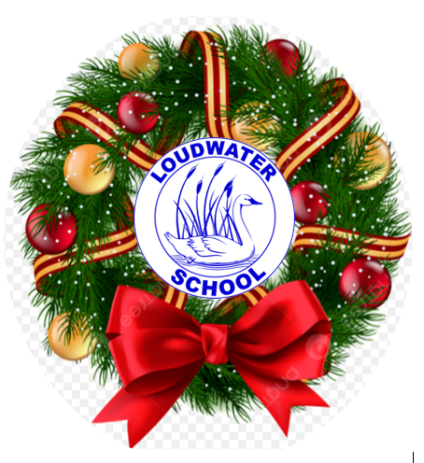
Loudwater Combined School
Learn, Create, Succeed
Head teacher:
Mrs. Clare Cunnington

LOUDWATER UPDATE
Friday 15th December 2023
a: School Way, Kingsmead Road
Loudwater, High Wycombe
Buckinghamshire
HP11 1JJ
t: (01494) 524919
e: office@loudwater.bucks.sch.uk
w: www.loudwater.bucks.sch.uk

Important Dates
Monday 18th December – Christmas Family Service
Christmas Parties and Disco
Last Christmas post and day to bring in donations for the One Can Trust Reverse Advent Calendar
Tuesday 19th December – School closes at 2pm
Monday 8th January 2024 – School reopens for the spring term

Dear Parents,

All you need to know about Christmas at Loudwater – reminder.

Christmas Post Box
This will stay out until 9.00 on Monday morning – we will then bring this inside for the final sorting and sending out to the children.

Christmas Family Service – 18th December
We are having our service of Carols and a retelling of the Christmas Story at St. Peter’s Church on Monday 18th December at 10.00 am. You are all most welcome to join us. The service will last approximately 45 minutes.

The children should come to school as usual on the day and at 9.40 a.m. all the classes will walk down to the church together. We would appreciate offers of help from parents to walk with us, but those parents accompanying our children must not have younger children with them – this is for health and safety and insurance purposes. We will use your consent for local walks as permission for your child to walk to the church.

Please contact the school office by Friday 15th December if you do not wish your child to attend the service, on religious grounds and arrangements will be made to supervise them in school.

Christmas Parties and Disco – 18th December
These are taking place on Monday 18th December. All children should come to school in their uniform, but can bring a change of clothes for the afternoon. If your child’s class normally has PE on a Monday this lesson will not be taking place. FOLS will be providing refreshments; children do not need to bring any money.

In order to set up the hall for the afternoon we are only having cold lunches on Monday, therefore if you have ordered a hot meal, please re-order or send you child to school with a packed lunch.

Foundation Stage and Key Stage 1 children will have the opportunity of going to the disco in the hall for the first part of the afternoon, followed by activities in their classes. Key Stage 2 children will begin the afternoon in their classes and have the opportunity to go to the disco for the latter part of the afternoon. Children who do not wish to go to the disco will be able to remain in classrooms.

Tuesday 19th December
Children finish school at 2.00 p.m.

News from the classes this week:
Foundation Stage
In Phonics this week, Foundation Stage has been revising all the sounds and all the Tricky words we have learnt since we started in September. We have been impressing our teachers with how much we have learnt in just one term!
Our main focus this week has been performing our Nativity play. We did it three times and on every occasion the adults said we did it really well and they were very proud of us. We also really enjoyed listening to Year 3 & 4's Carol Concert.
In Literacy and Maths we have done some "quizzes" this week, so that our teachers can see how we are getting on with our Reading, Writing and Number work.
Friday has been Christmas Jumpers, Christmas Lunch and Christmas Fun!

Please could we remind parents to sign the orange reading record so that staff know when children have read at home, and can change their reading book. Thank you.
The Reading Eggs programme has been provided by the school for us to use at home. You can access it via this website. Your individual login is in the front of the orange Home Reading Record book.
https://readingeggs.co.uk/

Year One
Our Christmas concert was fantastic and we hope that you enjoyed watching it as much as we enjoyed performing it! After the concert, we listened to the story of the first Christmas and sequenced pictures in order to retell the story. This week we have used a film text as our guided reading text. ‘Little Wolf’ by An Vrombaut. It is a great story and I have included the link to it here so that you can enjoy it at home too.
https://www.youtube.com/watch?v=C1f76YBhzE0
We have been very busy working on our DT project this week. We used straws and paper plates to design and make a chair for a teddy. We worked really hard on our structures and enjoyed designing, making, testing and evaluating them.
On Thursday we took part in a virtual assembly with the Blue Cross. We learnt about the hazards for pets at Christmas time. The Blue Cross have a great website with activities and information.
https://www.bluecross.org.uk/indoor-activities-for-kids
Other useful websites
https://www.topmarks.co.uk/christmas/ChristmasGames.aspx
This website has lots of different activities to keep you busy over the Christmas period.

Year Two
This week, in Guided Reading, we have completed the book ‘The Secret of Black Rock’. We have used the skill of retrieval to answer questions about the book. In Phonics, we have completed a spelling and reading quiz based on the sounds and rules we have been learning this term. In English, we read a poem called ‘My Christmas Tree’. We identified patterns in the poem and then wrote our own version. In Maths, we practised adding single and 2-digit numbers. In DT, we planned, created and evaluated our project, which was building a bridge structure out of sugar cubes. Our bridge had to be strong and stable. We really enjoyed this project and learned how to be resilient when building the arch of our bridge! Most of our week has been dedicated to performing our Christmas Nativity for our families and the other children in school. We thoroughly enjoyed performing our Nativity and we hope you enjoyed watching it as much as we enjoyed performing it.
Although Christmas is almost upon us, it is still important for the children to be reading regularly to their grown-ups at home. Please ensure your child is reading aloud to you over the Christmas holiday and record this in their reading diaries (this can be any book, not just their school book). Thank you!
https://readingeggs.co.uk/

Year Three
This week we have been preparing for our Year 3/4 Carol Concert at St Peter's Church. We rehearsed in school and performed our concert to the rest of the school. We then had a dress rehearsal at the church before performing two shows for our parents/carers.
In English, we continued learning about ‘The Fox and The Star’. We planned writing an alternative ending and used our plans to write our endings.
In Maths, we continued our learning on using different methods to multiply and divide by 8. To consolidate our learning this term, we completed an activity based on the 2, 4 and 8 times table.
In DT, we have been working on our shell structure designs. We evaluated our first designs and then discussed ways of improving them. We then made our second and final designs, based improvement comments on our evaluation sheets. In PSHE, we have been learning about cyber security and staying safe online. In this lesson, we learnt about why we have passwords and what makes a strong password. We then created some strong passwords based on these criteria. We also discussed 2-step verification and how it is used.
https://www.timestables.co.uk/8-times-table.html
https://ttrockstars.com/

Year Four
We enjoyed performing our songs and readings at the church this week and everyone did a fantastic job! During our English lessons this week we have been busy writing our letters to Lalchand, the Firework Maker, to tell him all about the events of the Full Moon Ceremony. We have tried hard to include descriptive noun phrases, fronted adverbials and a range of different sentence types in our writing. During our reading lessons, we have been reading ‘Loki Lends a Hand’ which is a Norse Myth. We have used our background knowledge about Vikings to make links to the text and what we already know, and have used our inference skills to think about how the other gods feel about Loki.
During our maths lessons, we have finished our learning for this unit on multiplication and division. We have found out what happens when we multiply three numbers together and represented this using counters. We have used our knowledge of the commutative law to multiply three numbers in different orders to make them easier to calculate.
In our topic lessons we have continued with our DT projects. We have thought about the purpose of a bridge and set about making truss bridges using our woodwork skills practised last week. We are looking forward to putting these together next week.
In our computing lessons, we used our knowledge of repeating patterns to create a wrapping paper design on turtle logo. In our RE lesson, we continued our work learning Hindu symbols and then recapped what we have learned during this half term's unit. In our PE lesson, we put our basketball skills to practice in small-sided games.
https://www.bbc.co.uk/bitesize/topics/zh86n39/articles/zmpp92p

Year Five
In English this week, we have published our narratives inspired by ‘The Promise’ by Nicola Davies. We found that typing up our written work provided us with another layer of proofreading and editing and many of us were able to make further adjustments to our stories. These will be proudly displayed outside our classroom in the New Year.
In Maths, we have continued to practise finding equivalent fractions as we have been challenged to add and subtract fractions and mixed numbers with different denominators. In DT, we have built our tetrahedral kite frames and added tissue paper according to our team design. We thought we had planned the materials we needed carefully, but most of us learnt a great lesson of double-checking lists and calculating string length twice at least! We will be testing out our kites next week so are hoping for a windy day on Monday or Tuesday!
In our final indoor PE lesson this Term, we rose to the challenge of speeding up our line-dancing routine to the Christmas song: ¡Feliz Navidad! by José Feliciano. We so enjoyed listening to Year 3 and 4’s Christmas performance and couldn’t resist joining in with Foundation Stage and KS1’s brilliant Nativity songs we remembered learning when we were little.
Finally, this week we have finished listening to/looking at everyone’s amazing World War II presentations – Mrs PC is very proud of all of our efforts and has been very generous with house points! Thank you so much to everyone who supported us with these projects at home.
As this is the final class news flash before Christmas, I would like to wish everyone a very Merry Christmas and restful break. Whilst I hope everyone continues to read regularly and completes a little extra Maths practice, I will only expect to see one week’s worth of home-learning (4 x Reading Journal entries and 1 quality activity due for Monday 8.1.24, and 60 minutes of Maths Whizz to be completed by Friday 12.1.24). Mrs PC. Login - Maths-Whizz

Year Six
In English this week, we have been working hard to complete our comic strips based on ‘Charles Dickens: A Christmas Carol’ written by Angela McAllister. We have tried our best to include the correct features and also retell the story through the pictures, speech and a limited number of sentences.
In Maths, we have been converting units of measure. We have been converting and calculating with metric measures, converting miles to kilometres and using imperial measures such feet and inches, ounces, pounds and stones and pints and gallons.
In our Design and Technology unit which is called Electronic Motors. We have been building our 4-wheeled vehicles and attaching a motor and pulley which will power the vehicle forward. This has been a challenging but enjoyable task where we have had to work together to overcome the obstacles that we have encountered. In PSHE we have looked at the way that the media portrays smoking, vaping and drinking alcohol and have explored the different messages given to either encourage or discourage us to smoke and drink. In Computing, we have added subpages and hyperlinks to our home page. In Music, we have been practising singing Hey Mr Miller. This week in class, we have been listening to music of Sam Cooke.
Websites:
Maths Whizz –https://whizz.com/
This forms part of the weekly home learning each week. The expectation is that 60 mins will be completed in total each week – this is measured from Friday to Thursday.
Geography – Some great pre-reading for our Geography unit in January on global trade
Fairtrade - https://www.fairtrade.org.uk/

Book Review
Please see this week’s book review by Mr Williams here.

Achievement Award Winners
 | Foundation Stage | Year One | Year Two | Year Three | Year Four | Year Five | Year Six
08.12.23 | Dylan S  Dylan K | Ollie | Harrison | Aadya | Ollie | Molly | Breagha
15.12.23 | All pupils | All pupils | All pupils | All pupils | Mason K | Darcy A | Julia

The following children have been recognised in achievement assembly for their good behaviour:
 | Foundation Stage | Year One | Year Two | Year Three | Year Four | Year Five | Year Six
08.12.23 | Saraya  Adam | Shi’loh  Daisy | Scarlett  Jessica | Harry  Maisie | Lucy  Diya | Amine  Max | Evan  Ellie-Louise
15.12.23 | Al Sudais  Aminah | Zoe  Lily | Avaya  Ailbe | Frankie  Aadya | James  Mason | Azhaan  Caleb | Taaha  Charlie

The following children, in KS2, have made particular efforts with Tables Rock Stars/ Maths Whizz:
 | Times Tables Rock Stars/ Maths Whizz
08.12.23 | Christopher – Y3  Eliza – Y4  Elizabeth – Y6
15.12.23 | Marley – Y3  Justyna – Y4  Darcy P – Y5  Eleithyia – Y6

The following children have made particular efforts with Reading Eggs or Accelerated Reader.
 | Reading Eggs | Accelerated Reader
08.12.23 | Lorenzo – FS  Hope – Y1  Sam – Y2 | Marley – Y3  Oliver – Y4  Tilly – Y6
15.12.23 | John – FS  Evie – Y2 | Maisie – Y3  Lucy – Y4  Elliotte – Y5  Kata – Y6

Attendance
 | Foundation Stage | Year One | Year Two | Year Three | Year Four | Year Five | Year Six
08.12.23 | 96% | 96% | 88% | 92% | 95% | 91% | 95%
15.12.23 | 95% | 89% | 95% | 92% | 92% | 96% | 95%

Punctuality
Number of children arriving after their class start time.
 | Foundation Stage | Year One | Year Two |  | Year Three | Year Four | Year Five |  | Year Six
08.12.23 | 1 | 2 |  | 1 | 4 | 2 |  | 5 | 1
15.12.23 | 4 | 3 |  | 1 | 6 | 6 |  | 5 | 2

House points for the week
 | Beethoven | Mozart | Tchaikovsky | Elgar
08.12.23 | 333 | 279 | 321 | 301
15.12.23 | 324 | 371 | 373 | 380

Update from Gemma (Family Support Adviser)
Gemma’s contact details:
Work mobile number: 07792 142825.
School email: gnortheast@loudwater.bucks.sch.uk

Family Information Service – Things to do this Christmas time
Please click on the link below to find out more information about events which will be taking place over the Christmas period that you can enjoy with your children. The weblink includes links to places where your child can meet Santa, Christmas events that you can attend with family and friends, Christmas markets, ice rinks and Christmas activities for children with SEND.
Things to do this Christmas 2023 | Family Information Service (buckinghamshire.gov.uk)

Helping your child with fears and worries
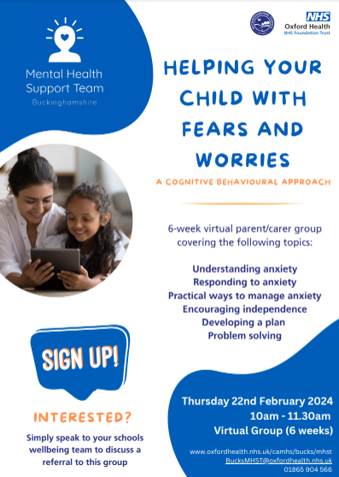
As a school, we work with the Mental Health Support Team to provide extra support for children and their families with regarding to their mental health and wellbeing.
The Mental Health Support Team are now advertising a 6-week parent/carer group that will focus on identifying, responding to, and managing child anxiety.
The following topics will be discussed:
- Understanding anxiety
- Responding to anxiety
- Practical ways to manage anxiety
- Encouraging independence
- Developing a plan
- Problem solving

The group will be starting after February half term, on Thursday 22nd February at 10am – 11.30am for 6 weeks.
If you would like to attend this group, please contact me directly and I can complete a referral on your behalf. You must be able to attend all six weeks of sessions for their referral to be accepted. If you have questions, please get in contact with me.

Family Learning courses
Please find attached the following Family Learning courses available to all parents/carers from January 2024.
The courses include the following:
- Happy, healthy and safe online - tips for Year 3 to Year 6 parents and carers
- Supporting your child with phonics- Foundation Stage
- Support Your Child with Maths (Shape Data and Measure) – Year 1 and Year 2
- Support Your child with Phonics and Reading – Year 1 and Year 2
- Shape, Data and Measurement - Years 3 and Year 4
- Develop your child’s Writing, Spelling, Grammar and Punctuation – Year 5 and Year 6

E-Safety awareness parents’ meeting
We know that E-safety is something that all parents are anxious to get right for their children. I hope that you have found some of the information provided on the newsletter helpful. To support parents further we have arranged for Alison Watts to speak about e-safety to parents; this will happen on 25th January 2024.
Alison works for Buckinghamshire Council and the Child Exploitation and Online Protection centre (CEOP). She has visited our school on a number of occasions and always has sensible, practical advice that helps to maintain a safe and heathy balance for our children.

Alison’s presentation last for about an hour. This is interactive and contains award winning awareness films, animation and statistics. The presentation covers new and emerging technologies that children and young people use, the potential risks they may face and easy technical and lifestyle solutions which parents can employ to help keep their children safe. These sessions aim to give parents and carers the knowledge, skills and confidence to better support their children to be safer from online child sexual abuse.
The training sessions cover:
- What parents and carers do well.
- What helps and hinders parents and carers from engaging with their children on the topic of Child Sexual Abuse.
- What children want and need from parents and carers.
- Top tips for parents and carers when supporting their child online.

We would like to think that many parents will find this something valuable to attend and would at this stage like to ask parents at which time of day they would find most convenient. The presentation will be either at 2.00pm or at 7.00pm. If you would like to attend, please visit the school gateway to indicate your preference; we will confirm the timing in January.

St Peter’s Church
Everyone is invited to Christmas Lunch on Christmas Day at 12noon. This lunch is for the community and all are welcome. If you know someone who may be alone or maybe your family is looking to join with others to celebrate this year then head to stpetersloudwater.org/christmas to book your place or email alison@loudwater.org – Children eat for free and there is a suggested donation for adults.
For further information regarding the Christmas lunch, please click here.
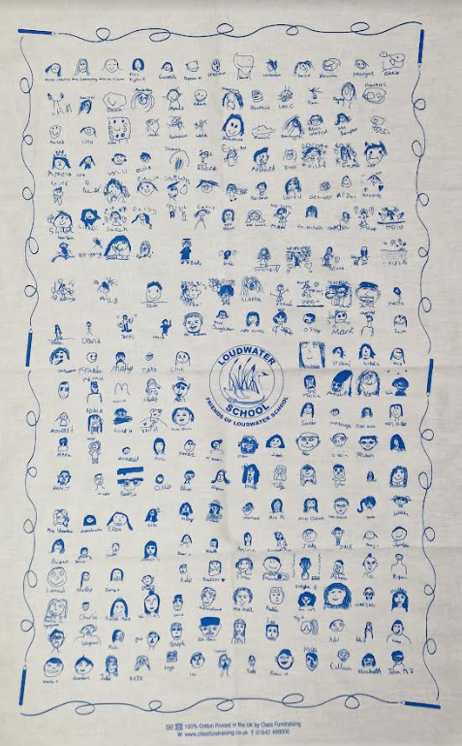
News from FOLS

Tea towels: Loudwater School tea towels were available for sale at the Christmas Bazaar. The remaining tea towels, with self-portraits by some of the children and teachers, will be available to buy on the Gateway from today. Prices are £4 per towel, 2 for £7.50 and 3 for £10.50. Numbers are limited so first come first served!

Yours faithfully

Clare Cunnington
Mrs C Cunnington
Head teacher

Disclaimer
From time to time, we are asked by a range of organisations to give out leaflets. We always agree if we think this could be of interest or benefit to the children. However, we do not endorse any of these organisations and parents should always check their credentials carefully to make sure children would be safe and well looked after.

External News

Children’s Commissioner for England – The Big Ambition
Please see the flyer for information regarding a survey that is being undertaken.

Eden Shopping Centre
We are extremely excited to announce that we have a BRAND-NEW event for Christmas – Eco Elves Tree-Cycle - and we would love for your pupils to join us for it! Striving for sustainable fun for the whole family, our ‘Eco Elves Tree-Cycle’ event will be our very first 100% sustainable event, which is something we as a centre are extremely proud of.
Children’s dreams of visiting the North Pole will become a reality as they step into Christmas inside our environmentally friendly festive workshop. From start to finish, they will experience the joy of Christmas as they transform a magic bean into their very own miniature Christmas tree with the help of Mrs Claus, our Christmas tree machine, and the Eco Elves. Children will then have the chance to get creative as they have fun making sustainable Christmas tree decorations using recycled craft materials.
Our Eco Elves Tree-Cycle opens on Saturday 25th November and will then run from 10am-5pm every weekend in the run up to Christmas, plus daily from 16th – 24th December.
There are limited spaces in each workshop and must be pre-booked in advance. Tickets cost just £3 and can be purchased at www.edenshopping.co.uk/events/the-eco-elves-tree-cycle.
Please also see the attachment for the flyer for this event.

LOUDWATER COMBINED SCHOOL
Calendar of events for 2023-24

December  Saturday 2nd – FOLS Christmas Bazaar 12.00pm – 3.00pm  12th 2.30pm Key Stage 1 Christmas Production  14th 9.30am Key Stage 1 Christmas Production  14th Y3 & Y4 Carol Concert 2.30pm & 7pm  15th Pupils’ Christmas Lunch & Christmas Jumper Day  Christmas Activities pm  18th Christmas Service 10 am  19th School closes at 2pm for Christmas break | January  4th & 5th School closed – training days for teachers  8th Children return to School | February  Week beginning 5th Parent /Teacher Consultations  12th - 16th Half term break  19th Return to School  Values Assemblies  All Start at 9.05am  24.1.24 Honesty Year 1  28.2.24 Love Year 3  23.5.24 Trust Year 2  26.6.24 Self-belief Year 6  18.7.24 Friendship Foundation Stage
March  1st Notification of Secondary School Places  7th World Book Day  8th Book Character Dressing up day  7th Parents’ Forum 7pm  Week beginning 25th Parent /Teacher Consultations Y6  27th Y5 Hispanic Evening for parents  28th School closes at 2pm for Easter Break | April  15th Children return to School  Week beginning 22nd Parent /Teacher Consultations (FS-Y5) | May  6th Bank Holiday  13th Year 6 SATs Week  20th Year 5 Assessment Week  27th – 31st Half term break
June  3rd School Closed Training Day for teachers  4th Children return to School  10th – 14th Year 6 residential  10th – 14th Assessment Week Y1, Y3 & Y4  28th School Closed  Training day for teachers | July  2nd Secondary School Induction Day (Y6)  New Parents Meeting  12th Sports Day  16th Reserve Sports Day 22nd 7.00pm Y6 Leavers Production  23rd 9.30am Y6 Leavers Assembly  School closes at 2pm for summer break | Class Assemblies  Spring term  9.05 Start  18th January - Year Six  25th January – Year Two  1st February – Year Four  29th February - Year One  7th March – Year Five  14th March – Year Three  21st March - Foundation Stage

