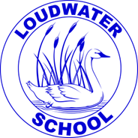

**Loudwater Combined School**

**Person Specification for Midday Supervisor**

**Experience**: Previous experience not required as training will be provided.

**Qualifications or**

**Training:** Experience of working with children is desirable but not essential.

**Practical Skills:** • Ability to communicate at all levels

• Ability to interact and play with children

• Ability to meet children’s needs

• A commitment to undergo training as and when required

• An understanding of equality of opportunity

**Personal Qualities**

**& Attributes:** • Ability to use judgement and common sense

• Ability to work as part of a team

• Flexible

• Honest

• Sense of humour

**Safeguarding Children:**

We are a Safeguarding School, you are required to implement and adhere to the school’s behaviour and safeguarding policies, ensuring the safety, health and well-being of pupils is maintained at all times and is of primary importance.