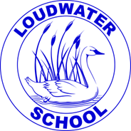

a: School Way, Kingsmead Road

Loudwater, High Wycombe

Buckinghamshire

HP11 1JJ

t: (01494) 524919

e: [office@loudwater.bucks.sch.uk](mailto:office@loudwater.bucks.sch.uk)

w: www.loudwater.bucks.sch.uk

Loudwater Combined School

*Learn, Create, Succeed*

Head teacher:

Mrs. Clare Cunnington

Dear Parents,

LOUDWATER UPDATE

Friday 28th June 2024

**Important Dates**

**Monday 1st July –** Year 3 visiting Flackwell Heath Library

**Tuesday 2nd July** – Transition day (see below)

**Thursday 4th July** – Mufti day for Fete donations for FOLS

**Friday 5th July** – Skipping Workshop (see below)

**Some things to note:**

**Induction Day**

Tuesday 2nd July is when children have the opportunity to spend some time with their new teachers during the morning; it is the day when Year 6 pupils visit their secondary schools.

We recognise that there are a number of changes to the teachers who will be teaching each year group from September. Therefore, we want to offer the opportunity for parents to meet their child’s new teacher at the end of the day on the 2nd July. This will be a short, informal drop-in time and not a time to share detailed information about your child; if you feel you need an opportunity to share important information an appointment can be made. Please contact the School Office by **email** to arrange this. Teachers will be available in their classrooms until about 4.00pm, giving you the opportunity to drop into several classes as needed.

**Dolce – School Meals**

Please be aware that we are reconsidering our school meal options from September and we would advise parents not to have a balance on their accounts that cannot be spent by the end of this term.

**Names in Clothing**

As the weather gets warmer, the children are taking off coats and jumpers or hoodies. Please could you check that these items in particular are still clearly named and that new items are named before you send your child in wearing them.

**News from the classes this week:**

**Foundation Stage**

This week we have learnt the digraphs ‘ie’ as in shield and ‘ea’ as in peach.

Our Literacy has been about "The Night Pirates". We wrote speech bubbles to show what Captain Patch said in the story.

In our Guided Reading, we have enjoyed the story "Rosie's Walk". It is a simple story of a hen's walk around the farmyard, but the pictures tell another story of the danger that Rosie is unaware of as she strolls.

In Maths, we have continued our learning about sharing. We have been finding ways of dividing between two people to make it fair. This week we worked out that sharing between 2 can be an easy way to find out if a number is odd or even. If it shares equally between 2, then it is even.

In PE, we have been enjoying the parachute game "Cat and Mouse".

We have also continued our learning about pirates with more mapping and some pirate hat making.

The Reading Eggs programme has been provided by the school for us to use at home. You can access it via this website. Your individual login is in the front of the orange Home Reading Record book.<https://readingeggs.co.uk/>

**Year One**

In English, we started our week by learning about the prefix ‘un’.

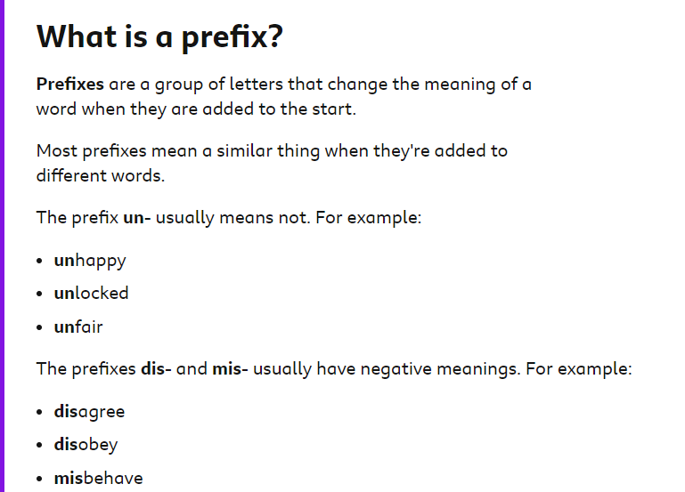

We found this definition very helpful.

We focussed on the prefix ‘un’ and played a matching game.

We also looked at how the prefixes ‘dis’ and ‘mis’ can alter the meanings of words.

We have been introduced to our new class text ‘The Tower’ by Joseph Coelho. We used adjectives to help us to describe the amazing tree that is at the centre of this story. In Guided Reading, we have completed ‘My Best Friend’ by Rob Hodgson. This is a brilliant book, which we all really enjoyed. We loved the characters of Mouse and Owl. In phonics we have been focussing on the sounds ‘sh’ written as ti (as in potion, station) and ‘o’ written as a (as in wasp, want). On Tuesday, we had an assembly by the author Mini Grey. This was a brilliant and very inspiring assembly. It was so exciting to meet a real life author and illustrator!

<https://readingeggs.co.uk/?scrlybrkr=42c75ca4>

In Maths, we are learning all about numbers from 50 to 100. We have been identifying numbers, counting forwards and backwards and partitioning these numbers into tens and ones using part-whole models and our base ten equipment.

<https://ictgames.com/sharkNumbers/mobile/>

<https://www.topmarks.co.uk/learning-to-count/paint-the-squares>

In Geography, we have enjoyed investigating the features around our school. We looked at an aerial view of the school and labelled the features. We learnt about why some maps have keys. We drew a map of a route from our classroom to the outdoor classroom and some of us added our own keys. In PSHE, we have been thinking about the question ‘how much energy do we waste?’ We identified ways that we do waste energy and then thought about what we can do to save energy.

<https://www.bbc.co.uk/bitesize/articles/zxxg3j6#zpggbqt> (information about saving energy and the reasons why it is important)

**Year Two**

In Phonics, we have been revising the sounds ‘ch’ in church, ‘tch’ in witch and ‘ture’ in adventure. We have practised reading and writing words with these sounds. In English, we have begun a new unit of learning using the film text ‘Bubbles’. We have learned how to read film using the skills of prediction and inference. On Monday, we visited Flackwell Heath library to borrow some new books for the classroom. On Tuesday, we had a wonderful day meeting Mini Grey, listening to her inspiring assembly and engaging in her workshop based on ‘The Last Wolf’.

In Maths, we have learned more about Statistics. We have been able to read a pictogram where the symbol equals 1 and pictograms where the symbol equals more than 1. We have also created our own pictograms and interpreted them by answering questions.

In PSHE, we explored how feelings can change and what we can do to help improve not so good feelings e.g. If you are happy because you have a bag of sweets but you eat too many and now you feel unwell. Next time, only eat a few and listen to your grown-up’s advice. In Geography, we have learned about the capital cities of London and Edinburgh. We explored landmarks, where the capital cities are on a map of the UK and how we might travel there. We also used compass directions to explain where the cities are in relation to Loudwater.

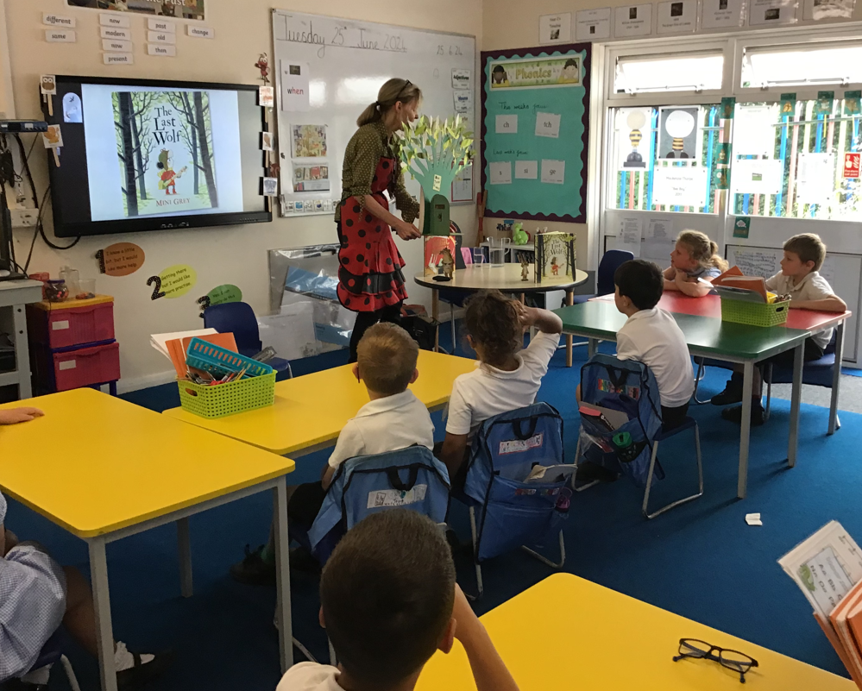

<https://readingeggs.co.uk/>

**Year Three**

This week, we enjoyed a super assembly with the author Mini Grey. She shared her inspiration behind writing and some of her wonderful stories with us. Mini also conducted a workshop where she demonstrated how she illustrates her books. The children had a great time creating their own illustrations of Scrubbing Brush and even got to design their own characters. In our writing lessons, we've been busy working on our information texts about education in Victorian times.

In Maths this week, we have continued our learning about shapes. We have been learning how to measure and draw shapes accurately using rulers. We have also been learning about different types of lines. We have learnt about vertical and horizontal lines as well as parallel and perpendicular lines. We finished the week by learning how to recognise and describe 2-D shapes.

Our focus in Geography has been on the rainforest and its diverse wildlife. We learned about the different animals that inhabit the rainforest and why they live in specific layers of this unique ecosystem.

Our Science lessons have been particularly exciting as we observed the growth of our seeds with some surprising results! Interestingly, the seeds kept in the cupboard have grown the most. We had discussions about why this might be, considering how the very hot weather might have affected the seeds left on the windowsill. Additionally, we explored how water is transported around a plant by placing the stems of three white roses in green, red, and blue food colouring. The children were amazed to see how the petals changed colour!

In PE, the children had a great time participating in hurdle relay races and learning how to throw the javelin.

<https://www.bbc.co.uk/bitesize/topics/zvmxsbk/articles/zcxy6g8>

<https://www.bbc.co.uk/bitesize/topics/zvmxsbk/articles/z98n4qt>

[https://play.ttrockstars.com](https://play.ttrockstars.com/)

**Year Four**

During our English lessons this week, we explored the life of the renowned Victorian heroine, Grace Darling. We looked into her story and found out about the rescue where she saved nine people from a shipwreck in a terrible storm. We looked at different examples of biographies and thought about what they tell us about people's lives. We also enjoyed our assembly and workshop with Mini Grey in the hall and loved exploring her book 'The Greatest Show on Earth' in more detail with her.

During our Maths lessons, we started our unit 'shape'. We learned the angles: right angle, acute angle and obtuse angle and we compared and ordered angles based on their size.

In our Geography lessons, we explored the different counties around the UK with the enquiry question 'what is a county?' We explored Buckinghamshire as a county and researched its topographical features to create a fact file. We also looked at the wider topography of the UK and compared two contrasting areas: The Highlands and South East England. In PSHE, we explored what is meant by 'risk' and thought about strategies that we could use to deal with it. In computing, we programmed our catching games using Scratch, programming our algorithms using a forever loop.

[Living in the UK](https://www.bbc.co.uk/bitesize/topics/zttbcmn/articles/zfk72v4)

**Year Five**

In Maths this week, we have been learning about decimal sequences and have multiplied and divided decimals by 10, 100 and 1,000.

In English, we began our final unit of the Summer Term. Following on from our Guided Reading unit on The Willow Pattern Story, we will be retelling this from the perspective of Chang or Koong Shee (characters from the myth). We identified the key events of the story, creating a chronological timeline, and also thought carefully about where we might insert an integrated setting or character description. Also, we brainstormed all the features that our end-of-unit narrative must contain and created a shared Writers’ Tool Kit. In Guided Reading, we were introduced to a new magical graphical novel: FArTHER by Grahame Baker-Smith. This is a fascinating story with many different interpretations which we will explore further next week. In Spanish, we verbally practised, then wrote sentences in the 3rd person linking someone’s else opinion to a sport. Finally, in Spelling lessons, we have been working with a partner to choose and spell tricky homophones using only a definition to guide us. Mrs PC has been very impressed with how we have risen to this challenge and tried our very best.

In Geography, we learnt about the characteristics of the tundra (a biome affected by extreme temperature and latitudinal factors). In PE, during our athletics lesson, we practised different jumping techniques and were encouraged to find and perfect our preferred and most efficient jump. Consolidate and extend our current Geography learning here: [What are biomes? - BBC Bitesize](https://www.bbc.co.uk/bitesize/articles/z2kj2v4#zvb8jsg)

**Year Six**

In English this week, we have continued to work hard on rehearsing our Year 6 production – The Pirates of the Curry Bean. Mrs Welland and Mrs Hall are really impressed with how well some of us have already learnt our lines. On Wednesday, we enjoyed presenting our values assembly on self-belief. Thank you to all the parents who were able to attend.

In Science, we have started a new unit of learning about light. We discussed what light is and where it comes from. We also explored the vocabulary – opaque, translucent and transparent. In our Computing lesson, we used the A and B buttons on the microbit to change the value of a variable. We then developed our programmes to update the variable by moving the microbit using the accelerometer to sense motion. In our Geography unit, we have explored Ordnance Survey maps this week. We used flash cards to test ourselves on our understanding of the map symbols used and looked for the symbols on OS maps. We then learnt recapped the eight compass points and extended our understanding of grid references to six digits using eastings and northings. We then applied this knowledge to an OS map of an area of London to follow treasure hunt clues (using compass points, grid references and scales). In PSHE, we continued to discuss the common feelings and anxieties associated with transitioning to secondary school. We thoroughly enjoyed the author visit (Mini Grey) on Tuesday and our Magistrates in the Community workshop on Thursday where we learnt all about the role of magistrates. We held a mock trial during the workshop where one member of the class was found guilty of a terrible crime!!!

Website

Youngminds – lots of useful advice and support for pupils and parents regarding transitioning to secondary school.

<https://www.youngminds.org.uk/professional/resources/supporting-school-transitions/?scrlybrkr=45346d01>

**Loudwater School Music Concert**

On Tuesday 16th July, we will be holding our annual Music Concert at St Peter’s Church. All children will be participating in this by singing a song that their class has been learning during their music lessons this year. Children who are in the choir or who are learning guitar at school will also perform several pieces. If your child learns an instrument outside of school and they would like to perform, please let Mrs Heard know by emailing her through the school office, including your child’s name and class as well as the instrument and the piece they would like to perform. Please could you let us have this information by Monday 8th July.

**Skipping Workshops**

On Friday 5th July, FOLS have kindly arranged and funded a skipping workshop with the Skipping Ninja. All children will participate in a workshop during the day with their class. On this day, all children should come to school in their PE kits; Year 3 will have their swimming lesson during the morning as usual. At the end of the day, there will be merchandise to purchase if parents would like to. Further are attached to the newsletter.

**Citizen of the month**

|  |  |  |  |  |  |  |
| --- | --- | --- | --- | --- | --- | --- |
| Foundation Stage | Year One | Year Two | Year Three | Year Four | Year Five | Year Six |
| Amina | Emma | Blake | Mark | Magda | Darcy A | Leo |

**Achievement Award Winners**

|  |  |  |  |  |  |  |  |
| --- | --- | --- | --- | --- | --- | --- | --- |
|  | Foundation Stage | Year One | Year Two | Year Three | Year Four | Year Five | Year Six |
| 07.06.24 | Hallie | Hope | Jess H | Yanis | Dylan | Lilah | Evan |
| 14.06.24 | Frankie L | Ahmed | Maya | Nyah | Magda | Caleb | Residential |
| 21.06.24 | Lorenzo | James | Rose | Eesa | Marcellus | All pupils | Sulaymaan |
| 28.06.24 | Liam | Ollie | David | Sam | Alyssa | Elliotte | Max |

**The following children have been recognised in achievement assembly for their good behaviour:**

|  |  |  |  |  |  |  |  |
| --- | --- | --- | --- | --- | --- | --- | --- |
|  | Foundation Stage | Year One | Year Two | Year Three | Year Four | Year Five | Year Six |
| 07.06.24 | Eddie  Dylan S | Ivy  Peter | Sam  Rose | Moleigh  Nyah | Tilly  Emily | Denise  Caleb | Finley  Rose |
| 14.06.24 | Ruairi  Nancy | Maya  Ollie | Otilia  Jayden | Sania  Sam | Eliza  Rahin | Darcy P  Kelci | Residential |
| 21.06.24 | Leo C Saraya | Maya  Daisy | Maya  Ailbe | Marley  Frankie | Raees  Lilien | Isla  Max | Julia  Joseph |
| 28.06.24 | Francesca  Raheem | Dexter  Eshal | Sienna  Prince | Lily E  Frankie | Thomas  Pippa | Charlie  Aoife-Rose | Evan  Breagha |

**The following children, in KS2, have made particular efforts with Tables Rock Stars/ Maths Whizz:**

|  |  |
| --- | --- |
|  | Times Tables Rock Stars/ Maths Whizz |
| 07.06.24 | Lily E – Y3  Oliver – Y4  Aoife-Rose – Y5  Kata – Y6 |
| 14.06.24 | Eesa – Y3  Jaden – Y4  Samuel – Y5 |
| 21.06.24 | Felicity – Y3  Alyssa – Y4  Mei – Y5  Mark – Y6 |
| 28.06.24 | Yanis – Y3  Jaden – Y4  Evalyn – Y5  Mia – Y6 |

**The following children have made particular efforts with Reading Eggs or Accelerated Reader.**

|  |  |  |
| --- | --- | --- |
|  | Reading Eggs | Accelerated Reader |
| 07.06.24 | Dylan K – FS  Julia – Y1  Sithuli – Y2 | Abbie – Y3  Kallia – Y4  Isla – Y5  Taaha – Y6 |
| 14.06.24 | Jacob – FS  Ivy – Y1  Evie – Y2 | Eesa – Y3  Mason – Y4  Darcy A – Y5 |
| 21.06.24 | Margot, Jacob R – FS  Yan – Y1  Holly – Y2 | Moleigh – Y3  Diya – Y4  Paige – Y5  Eleithyia – Y6 |
| 28.06.24 | Ruby – FS  Yan – Y1  Holly – Y2 | Noemi – Y3  Amelia -Y4  Samuel -Y5  Mark – Y6 |

**Attendance**

|  |  |  |  |  |  |  |  |
| --- | --- | --- | --- | --- | --- | --- | --- |
|  | Foundation Stage | Year One | Year Two | Year Three | Year Four | Year Five | Year Six |
| 07.06.24 | 98% | 83% | 90% | 91% | 93% | 95% | 95% |
| 14.06.24 | 92% | 92% | 89% | 99% | 94% | 95% | Residential |
| 21.06.24 | 96% | 94% | 91% | 92% | 94% | 89% | 91% |
| 28.06.24 | 95% | 83% | 93% | 98% | 96% | 93% | 95% |

**Punctuality**

Number of children arriving after their class start time.

|  |  |  |  |  |  |  |  |
| --- | --- | --- | --- | --- | --- | --- | --- |
|  | Foundation Stage | Year One | Year Two | Year Three | Year Four | Year Five | Year Six |
| 07.06.24 | 4 | 0 | 6 | 0 | 3 | 3 | 0 |
| 14.06.24 | 6 | 0 | 6 | 0 | 5 | 2 | Residential |
| 21.06.24 | 4 | 0 | 5 | 3 | 5 | 2 | 0 |
| 28.06.24 | 3 | 0 | 4 | 2 | 4 | 4 | 0 |

**House points for the week**

|  |  |  |  |  |
| --- | --- | --- | --- | --- |
|  | Beethoven | Mozart | Tchaikovsky | Elgar |
| 07.06.24 | 198 | 224 | 232 | 186 |
| 14.06.24 | 228 | 244 | 210 | 227 |
| 21.06.24 | 263 | 281 | 290 | 284 |
| 28.06.24 | 328 | 248 | 269 | 355 |

**News from FOLS**

**Reminder: Summer Fete Saturday 13th July**FOLS will be collecting jars for the children’s tombola which they can fill with sweets, chocolates, toys, the list is endless. If you have a jar ready, please bring along on Thursday 4th and Friday 5th July at drop off where a member of FOLS will be happy to collect it. Please remember no nuts, used or out of date items.  
Also we have arranged with the school for all children to have a mufti day on Thursday 4th July - in return we are asking for bottle donations for the adult tombola - we will accept any bottles such as alcohol, soft drinks, bubble bath, perfume etc! So please bring along your donation when dropping your child/children off to school on Thursday 4th July.  
We will shortly be sending around a link for volunteers to help at the school fete, we are only asking for 90mins of your time so please sign up if you are free as we will not be able to run the fete without the help of volunteers! Many thanks

**Easyfundraising**

Have you seen our new easyfundraising gate banner? It’s all about how you can support our school and your child for free when you shop online with over 8000 retailers. Everything counts – food shops, holidays, clothes, insurance, electricals and more! All the big names like Sainsbury’s, M&S, Argos and Just Eat are ready to donate at no extra cost to you. Find out more and sign up to support us today: <https://www.easyfundraising.org.uk/loudwatercombined>

**Buckinghamshire Mental Health Support Team**

The Bucks MHST are running a Summer Wellbeing Camp. Please see the attached flyer for details regarding this. The form to register for this can also be found as an attachment to the email you will receive for this newsletter – please note that the forms need to be sent directly to [bucksmhst@oxfordhealth.nhs.uk](mailto:bucksmhst@oxfordhealth.nhs.uk) and not back to the school office.

**SEND Support Sessions – Please select** **here**

Yours faithfully

**Clare Cunnington**

Mrs C Cunnington

Head teacher

**Disclaimer**

From time to time, we are asked by a range of organisations to give out leaflets. We always agree if we think this could be of interest or benefit to the children. However, we do not endorse any of these organisations and parents should always check their credentials carefully to make sure children would be safe and well looked after.

**Aylesbury on Sea**

The event, which takes place on Sunday 7 July in Vale Park, will be a day filled with seaside fun, games and activities as well as 60 tonnes of sand!

Event details

☀️ Punch and Judy shows  
☀️ Singing mermaid  
☀️ Land train  
☀️ Mini golf  
☀️ Prize bingo  
☀️ A cheeky giant seagull duo  
☀️ Unbound Theatre presents “The Sinister Seaside”  
☀️ Flotsam and Jetsam’s Voyage to the Trash Vortex eco-friendly adventure  
☀️ Face-painting with Zoomania  
☀️ Super soaker arena*, limbo, volleyball (*weather permitting)  
☀️ Chair-o-planes and teacups  
☀️ Arts, crafts, games

All to be enjoyed for the whole family for free!

The event accessibility information is available at [https://bit.ly/ATCAccessibility](https://bit.ly/ATCAccessibility?fbclid=IwZXh0bgNhZW0CMTAAAR2juoLLfYNkW8PbjafFJu7QZ06D_PxibH2UVVxh7rz1CzmigfcHQZpn7JM_aem_5yQhDPVOuqyWPKv5hSyCIA). A visual story helps those who wish to know more about Aylesbury Town Council's event and what to expect. Click here to view the visual story to assist those who may be overwhelmed by the event ➡️ [https://bit.ly/4bJe2hU](https://bit.ly/4bJe2hU?fbclid=IwZXh0bgNhZW0CMTAAAR1ik1lz55VtK4rKH53w6uw_YfQvTKJu1zhE9kedpTuxLKTb99yTFEqlW3g_aem_Fmx9886H9YNYHHsnqqq2Xw). View the visual story video here ➡️ [https://bit.ly/VSAOS2](https://bit.ly/VSAOS2?fbclid=IwZXh0bgNhZW0CMTAAAR2TZQfcS1Ws_USEfXxcEJkB-vq_eSz4wN46NHwIs9m9J2ruIaj0LAtogRQ_aem_ucrTavMo0Q1Uxq7M7g20qg).

**LOUDWATER COMBINED SCHOOL**

**Calendar of events for 2023-24**

|  |  |  |
| --- | --- | --- |
| **June**  3rd School Closed Training Day for teachers  4th Children return to School  10th – 14th Year 6 residential  10th – 14th Assessment Week Y1, Y2, Y3 & Y4  27th Class photographs  28th School Closed  Training day for teachers | **July**  2nd Secondary School Induction Day (Y6)  New Parents Meeting  12th Sports Day  13th FOLS Summer Fete  16th Reserve Sports Day  22nd 7.00pm Y6 Leavers Production  23rd 9.30am Y6 Leavers Assembly  School closes at 2pm for summer break | **Values Assemblies**  All Start at 9.05am  26.6.24 Self-belief Year 6  18.7.24 Friendship Foundation Stage |